Request Pickup Configuration

There are many different types of requests in Alma. Seven of them trigger title-level physical item requests. We can set up (configure) how Alma behaves when a request is placed.

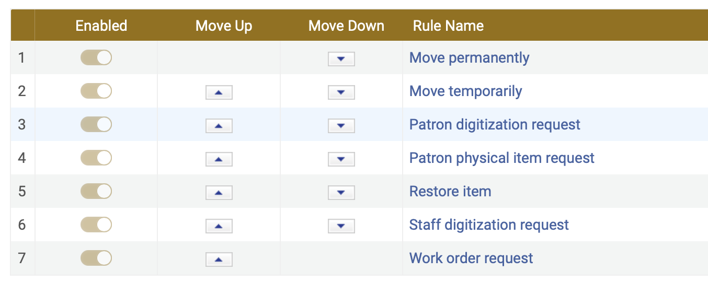

Here is what the setup page looks like in the backend (Configuration):

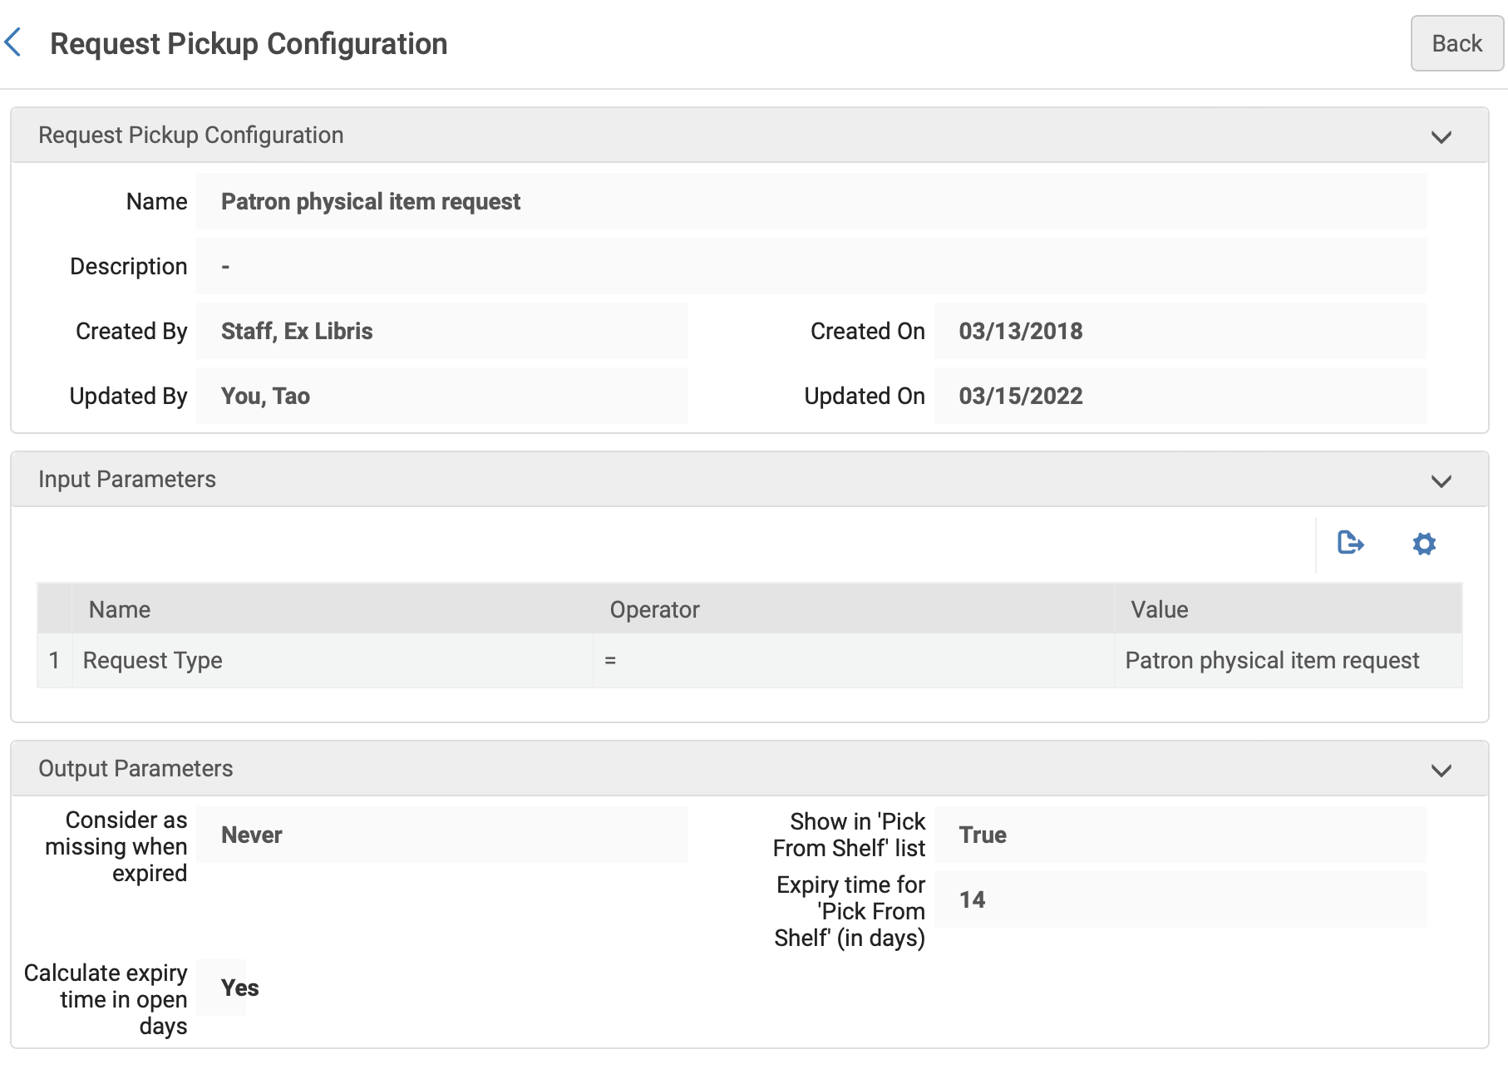

At configuration, VUL retained the system defaults for all requests.
- Show in ‘Pick From Shelf’ list = True
- Expiry time for ‘Pick From Shelf’ (in days): 7
- Consider as missing when expired: Always
- Calculated expiry time in open days: No.

Note that these options differ from the screenshot above.

Each request type can have different options, although it should be considered that multiple options for different request types could make understanding the behavior of Pick from Shelf list more complicated.

Show in ‘Pick From Shelf’ list: True OR False.

This is how Alma notifies staff that a requested item is available. It should always be “True”.

Expiry time for ‘Pick From Shelf’ (in days): [Enter the number of calendar days or open days before an unprocessed request is expired and removed from the Pick From Shelf list]

Alma refers to Opening Hours calendars to determine open days.

Note that a patron can create an expiry date that overrides the number of days we specify when they specify a Date Needed By in the request. [Update from Tao 2022-11-29: We can hide the option for patrons to specify a Date Needed By].

Why doesn’t an unprocessed request for an available item stay in the system forever? Presumably, Ex Libris’ thinking was that the requested item would no longer be useful to the requestor after a certain window of time has passed. Expiring the unfulfilled request either releases the item to be used by others or automatically considers the item as missing. It also automatically cleans up unfulfilled requests from the system (there is still a record of unfulfilled requests in Analytics).

Can we specify that Pick From Shelf requests should never expire? No.

Consider as missing when expired: Always OR Never OR Only when expired not due to Date Needed By.

Why would Alma ever automatically consider a requested item as Missing? Presumably, to 1) automatically give the requestor a reason as to why their request wasn’t filled; and 2) to indicate to those who manage inventory that there might be a problem with the item.

What does “Only when expired not due to Date Needed By” mean? Since patrons can create a very short window before a request expires, it may be preferrable to assume that staff couldn’t process the request in time rather than to assume the request couldn’t be processed because the item was missing.

What if circumstances are such that I can’t get into my physical space to process requests? There are two options. You can set your Alma Opening Hours to Closed and set Calculate expiry time in open days = True. You can also temporarily extend the Expiry time for ‘Pick From Shelf’ (in days). Note that both options will not help if a patron has set their own Date Needed By.

Calculate expiry time in open days: Yes OR No

Selecting Yes will use the number specified in Expiry time for ‘Pick From Shelf’ in combination with your Alma Opening Hours list to calculate an expiry day. Selecting No will calculate the expiry time in calendar days.

Drafted by Michael C. Jones 03/2022

